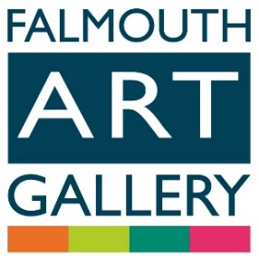
Imagine Falmouth

23 November 2019 – 18 January 2020
Submission Form
Sponsored by:


‘Imagine Falmouth’ our bi-annual open exhibition and arts prize is returning this year. We would like to invite established and emerging artists based in Cornwall to submit their very best work to be considered. Works will be selected for the exhibition by a panel made up of gallery staff, independent curators and the Falmouth community who will view a slideshow of the submitted images. The artist’s prize winners will be selected from the exhibition by an independent judging panel of artists and curators with an additional public vote prize. Artist names will not be revealed to the panels until after the selection.

Categories:

Artist’s Prize: £750
Public Choice Prize: £100
Under 18s Prize:
5 winners will be selected to be part of the main exhibition with additional prizes of art materials.

Terms and Conditions:

- One artwork per artist not to exceed a width of 125 cm.
- Open theme and medium but we ask that artists please be aware of Falmouth Art Gallery’s family friendly audience as this will be taken into consideration during selection.
- Artwork must have been completed in the last 12 months.
- Free to enter and open to all emerging and established artists.
- Submission by email to intern@falmouthartgallery.com entries to include a completed entry form and digital image (Jpeg or TIFF not to exceed 1 megabyte with artist and title as file name).
- Closing date for entries 4 October 2019
- Successful artists will be notified by 25 October. Works to be delivered for the exhibition by 18 November. They must be framed and mirror plated on the centre line or produced on a support that is ready for hanging with mirror plates.
- The judge’s decision is final.

Artist:

Address:

Email:

Telephone:

Category (Artist’s Prize or Under 18 Prize)

DETAILS OF ARTWORK:
Artist:
Title:

Medium:
Date:

Size of artwork (cms):

Size of frame (cms):

All works submitted for this exhibition should be framed and mirror plated on the centre line or produced on a support that is ready for hanging with mirror plates. If you would like to discuss your submission before entering please email info@falmouthartgallery.com

CAPTION PRICE including 35% commission (if works are for sale)
£___________________

PAYMENT DETAILS (if work should sell during exhibition
Please give the name as you would like it to appear on the cheque below:

NAME: ____________________________

Additional relevant information about the artwork (process, inspiration etc):

Signature: ……………………………… Date: ………………………

Deadline for submissions is 18 October 2019
Please email completed entry form and digital image (Jpeg or TIFF not to exceed 1 megabyte with artist and title as file name) to intern@falmouthartgallery.com
Judging will take place in October and you will be notified if you are selected for the exhibition you will be notified by 25 October 2017

